# **Project Report**

Jenil Sanjaykumar Pandya 1017921730

Pratham Ramkripal Yadav 1017895120

Introduction:

This project focuses on developing a deep-learning model to detect three different objects commonly found in household settings, such as cups, plates, bags, coins, pots, and chairs. The objective is to create a model capable of accurately identifying these objects in images. The project comprises several key steps, including data preparation, model development, and implementation.

1- Data Preparation: The team is tasked with generating a dataset of at least 300 images, with a minimum of 100 images for each object category. Additionally, at least 20% of the images should contain two or more objects to simulate real-world scenarios.

2- Model Development: The project involves developing a deep-learning model to recognize the specified objects in the dataset. The model should be capable of accurately identifying and labeling objects in images.

3- Implementation: Two implementation options are provided. The first option involves using a complex model that runs on a laptop or desktop computer. The second option is to use a simpler model that can run on mobile devices such as phones. If the mobile option is chosen, the model should include a touch button interface for user interaction. When activated, the program should be able to recognize objects in the image and provide labels accordingly.

Overall, the project aims to detect real world objects by leveraging the power of deep learning neural networks.

Project Description:

We have developed an object detection model using YOLO v8 to detect mouse, spoons, and cups. The model is trained to identify these objects in images, providing bounding box coordinates and class labels. It was trained on a dataset containing images of these objects from various angles and lighting conditions. The model achieved high accuracy after training for 311 epochs overnight. The project showcases the ability to implement advanced computer vision techniques for real-world applications.

Summary Of the Tasks That We Have Done

1. Data Collection: Collected images of mice, spoons, and cups from various sources to create a diverse dataset for training the object detection model.
2. Data Preprocessing: Converted images to a standard format, resized them, and ensured uniformity in lighting conditions to prepare them for annotation.
3. Data Annotation: Used tools like Roboflow to annotate each image by creating bounding boxes around the objects of interest (mouse, spoons, cups) to provide ground truth labels for training.
4. Dataset Creation: Split the annotated data into train, test, and validation sets to create a dataset that the model can learn from and generalize to unseen data.
5. Model Selection: Selected YOLO v8 as the model architecture for its efficiency and effectiveness in detecting objects in real-time applications.
6. Model Training: Trained the selected YOLO v8 model on the annotated dataset for 311 epochs overnight to learn the patterns and features of mice, spoons, and cups.
7. Result Evaluation: Evaluated the trained model's performance on the validation set, analysing metrics such as precision, recall, and mean average precision (mAP) to assess its effectiveness in detecting and localizing objects.
8. **Copy of our Programs with Documentation is Attached with Submission**

Detail Implementation of what we did on each step and What Problems we Encountered.

Data Collection:

* Objective:To build a robust object detection model for cups, mouse, and spoons.
* Method: Photographs were taken at various locations, under different lighting conditions, and from different angles.
* Diversity: Ensured diverse backgrounds, poses, and orientations for each object class.
* Quantity: Collected a dataset of 400 images to train the model effectively.
* Quality: Images were captured with high resolution and clarity for accurate annotation

Data Preprocessing:

* Conversion to JPG: All images were converted to JPG format for uniformity.
* Standardization: Resized all images to a standard format.
* HEIC to JPG: Converted HEIC images to JPG for compatibility.
* Quality Preservation: Ensured minimal loss of image quality during conversion.
* Uniformity: Standardized image sizes for consistent training data.

Data Annotation

* Platform: Used Roboflow for efficient and accurate data annotation.
* Manual Annotation: Created bounding boxes for each object in the images.
* Efficiency: Leveraged Roboflow's tools for faster annotation.
* Accuracy: Ensured precise annotation for training the object detection model.
* Quality Control: Reviewed annotations to maintain high-quality dataset.
* Splitting Data: Utilized Roboflow to split images into train, test, and validation sets.

Dataset Creation

* Customization: Specified the amount of images for each set to suit project requirements.
* Download: Dataset downloaded in a structured format for easy integration into the training pipeline.
* XML Files: Included XML files with detailed annotations for each image.
* Class Information: Each bounding box is annotated with the corresponding class name which is included in XML data.

Model Selection

* Options: Various models available for object detection, including Faster R-CNN, SSD, and YOLO (You Only Look Once).
* Choice: Selected YOLO v8 model for its efficiency and accuracy.
* YOLO v8 Advantages:
* Speed: YOLO v8 is known for its fast inference speed, making it suitable for real-time applications.
* Accuracy: Provides competitive accuracy compared to other models, ensuring reliable object detection.
* Simplicity: YOLO v8's single-stage architecture simplifies the training and deployment process.
* Customization: YOLO v8 allows for easy customization and adaptation to specific project requirements.

Model Training:

* **Training Time**

Trained the model for a total of 11 hours.

Used 311 epochs for training.

* **Training Process**

Overnight training on the training images.

Used the YOLO v8 model architecture.

* **Validation Output**

Saved the output for the validation images.

Stored in the "runs" folder for analysis.

* **Model Accuracy**

Monitored and recorded model accuracy parameters.

* **Results**

Achieved a high level of accuracy on the validation set.

Model is ready for deployment and inference on new images.

Result Evaluation

* Evaluated the trained model's performance on the validation set,
* analysing metrics such as precision, recall,
* and mean average precision (mAP) to assess its effectiveness in detecting and localizing objects.

**PROPOSED METHOD**

YOLO Working

* Single Shot Detection: YOLO is a single-stage object detection model that predicts bounding boxes and class probabilities directly from full images in one evaluation.
* Feature Extraction: Employs a convolutional neural network (CNN), such as Darknet, to extract features from the input image.
* Grid Division: Divides the input image into an 𝑁×𝑁 grid.
* Bounding Box Prediction: Each grid cell predicts multiple bounding boxes along with confidence scores.
* Class Prediction: For each bounding box, YOLO predicts the class probabilities.
* Non-Max Suppression: Post-processing step to remove duplicate boxes and refine the final predictions.
* Output: Provides a final list of bounding boxes with corresponding class labels and confidence scores.

**How have we collected data? How did we Collect Our Images?**

We collected our images by taking photographs in various locations,

including our house,

the Roger Glass Centre,

and a nearby dollar store.

To ensure diversity, we captured images under different lighting conditions at each location.

We used our mobile phones for photography, with some images taken by Jenil using an iPhone and others by Pratham using an Android mobile phone.

**Sample**:

1. Cup Sample Image:

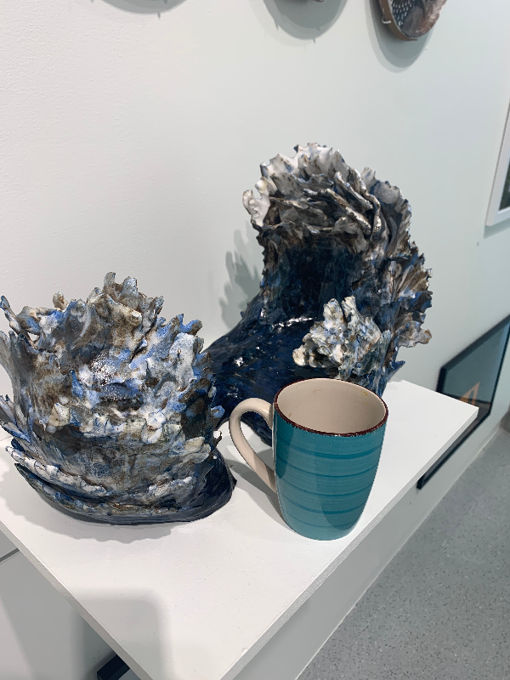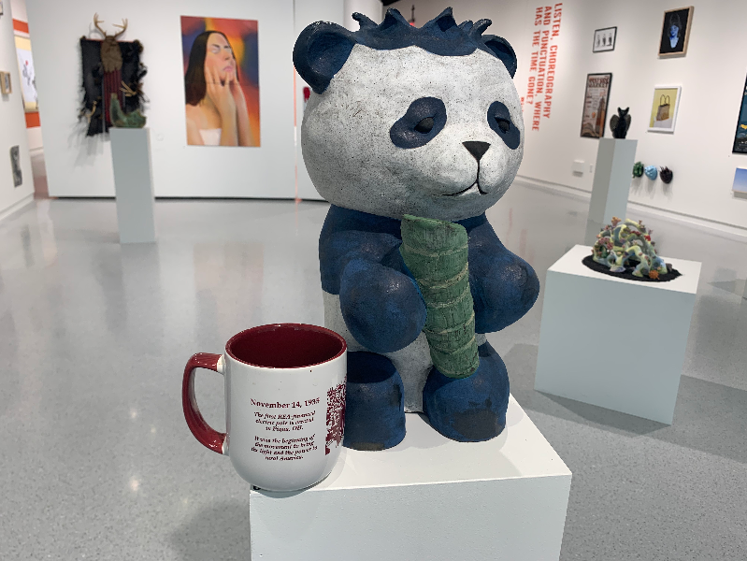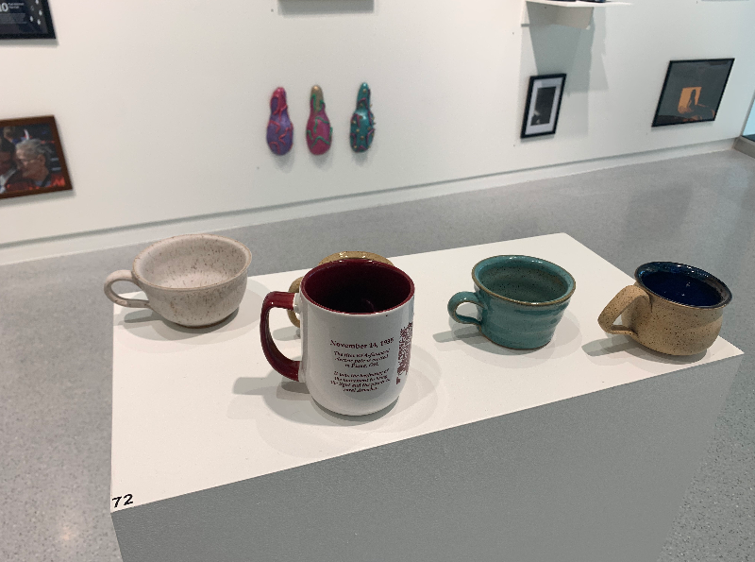

1. Spoon Sample Image:

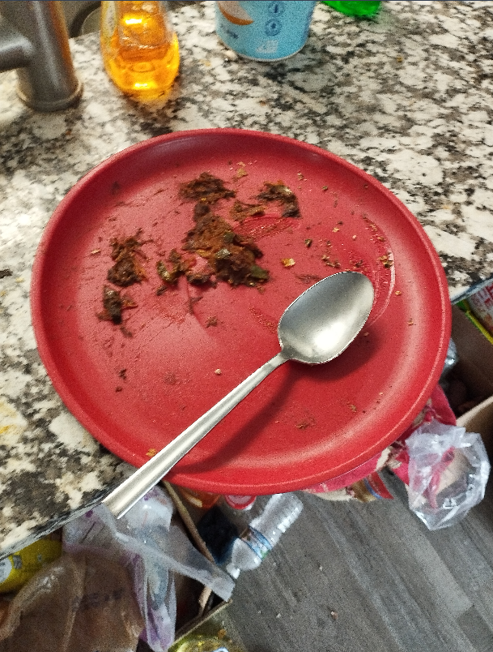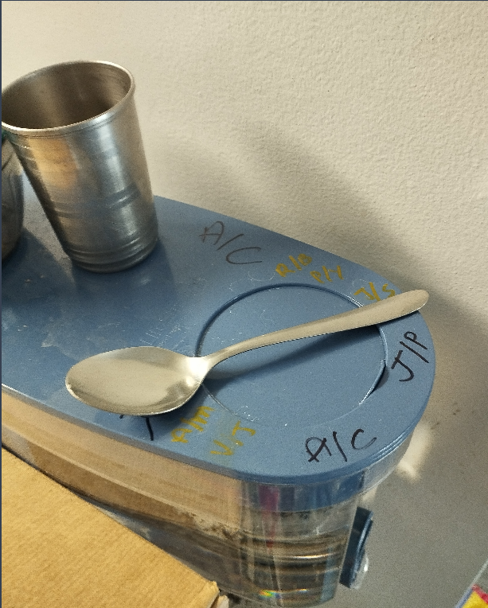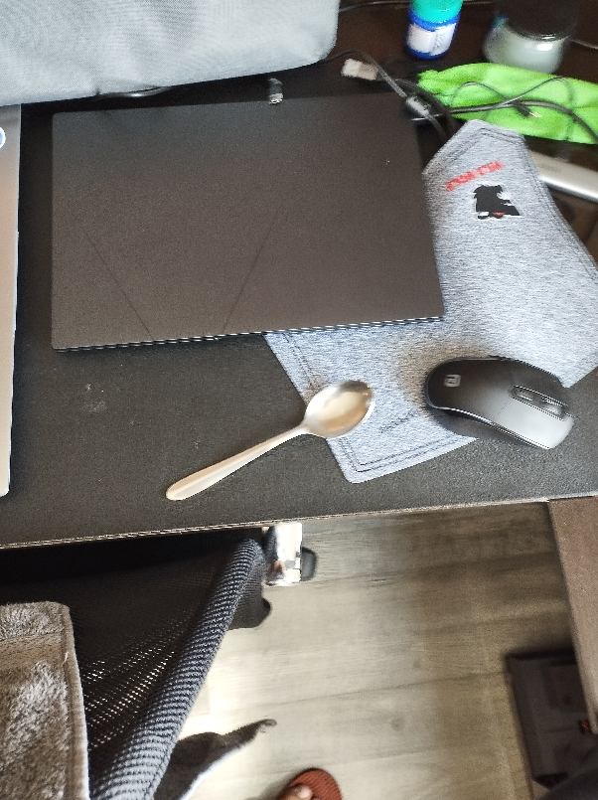

1. Mouse Sample Image:

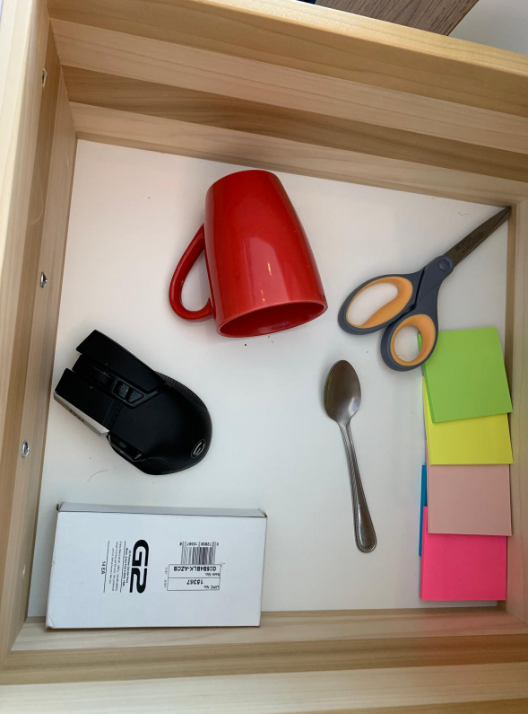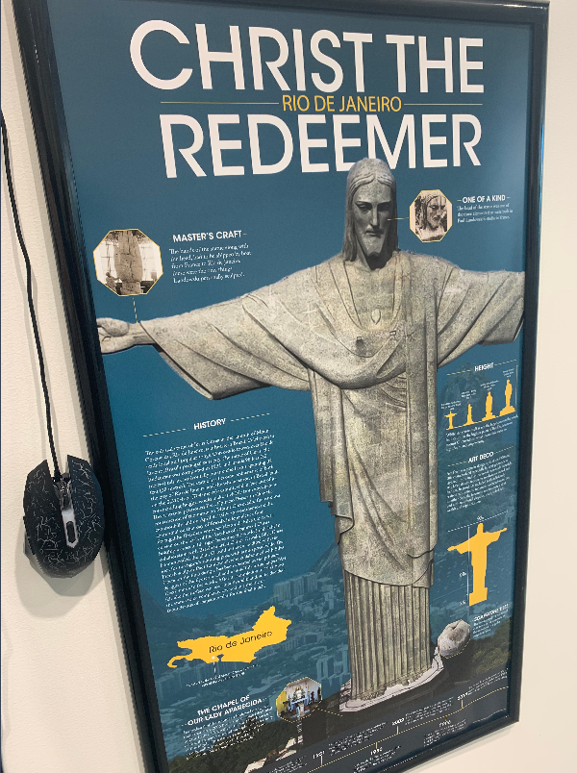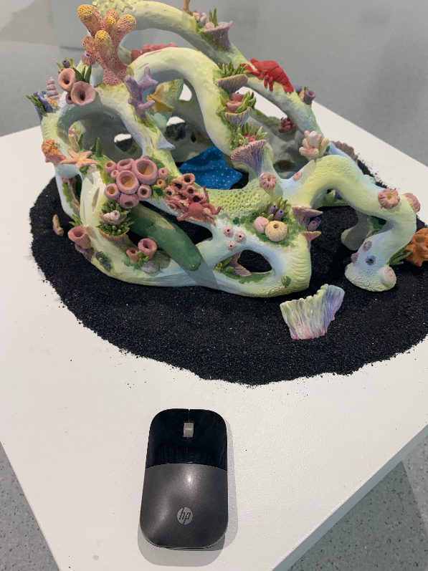

**Result Evaluation:**

After training a YOLOv8 model, you can evaluate its performance using various metrics. Common metrics for evaluating object detection models include:

**mAP (mean Average Precision)**: A popular metric that combines precision and recall across different levels of object detection confidence thresholds. It provides a single value that summarizes the model's performance across all classes.

**Precision**: The ratio of true positive detections to the total number of predicted positive detections. It measures the model's ability to avoid false positives.

**Recall (Sensitivity)**: The ratio of true positive detections to the total number of actual positive instances. It measures the model's ability to detect all relevant instances.

**F1 Score:** The harmonic mean of precision and recall. It provides a single metric that balances both precision and recall.

**IoU (Intersection over Union)**: A metric that measures the overlap between the predicted bounding box and the ground truth bounding box. It is used to determine if a detection is valid or not.

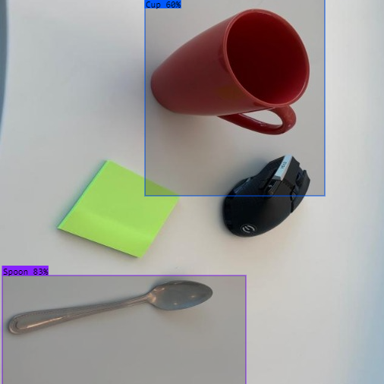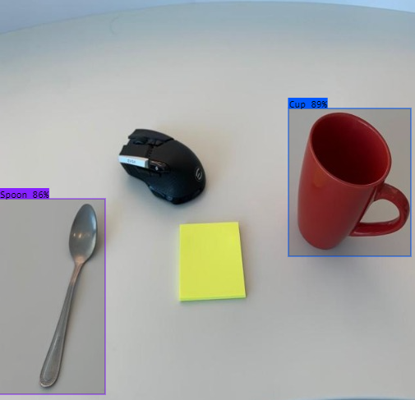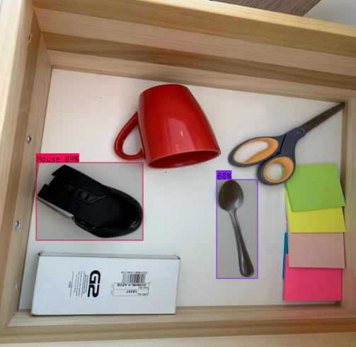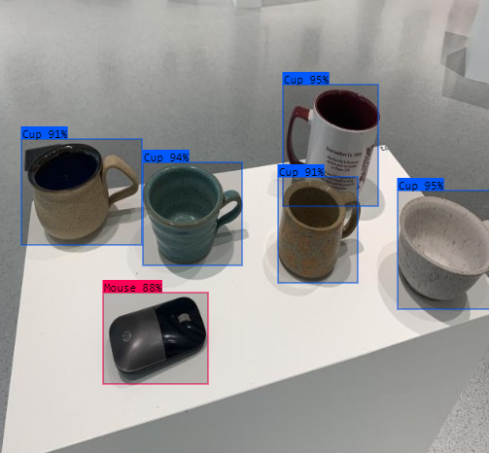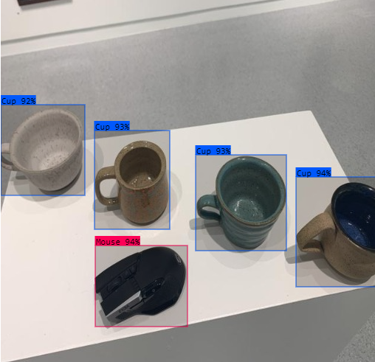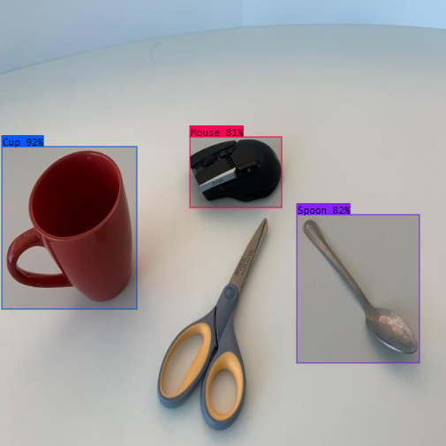

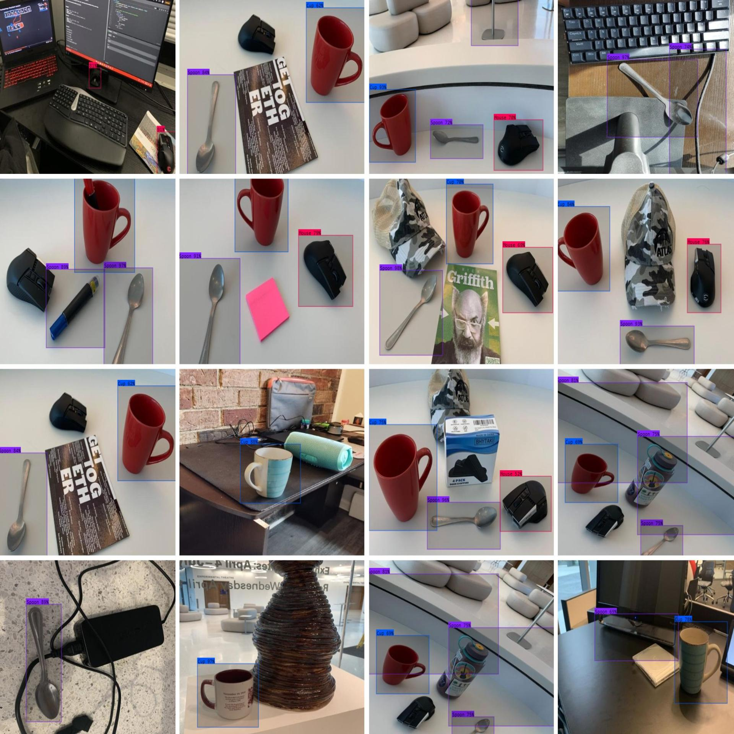 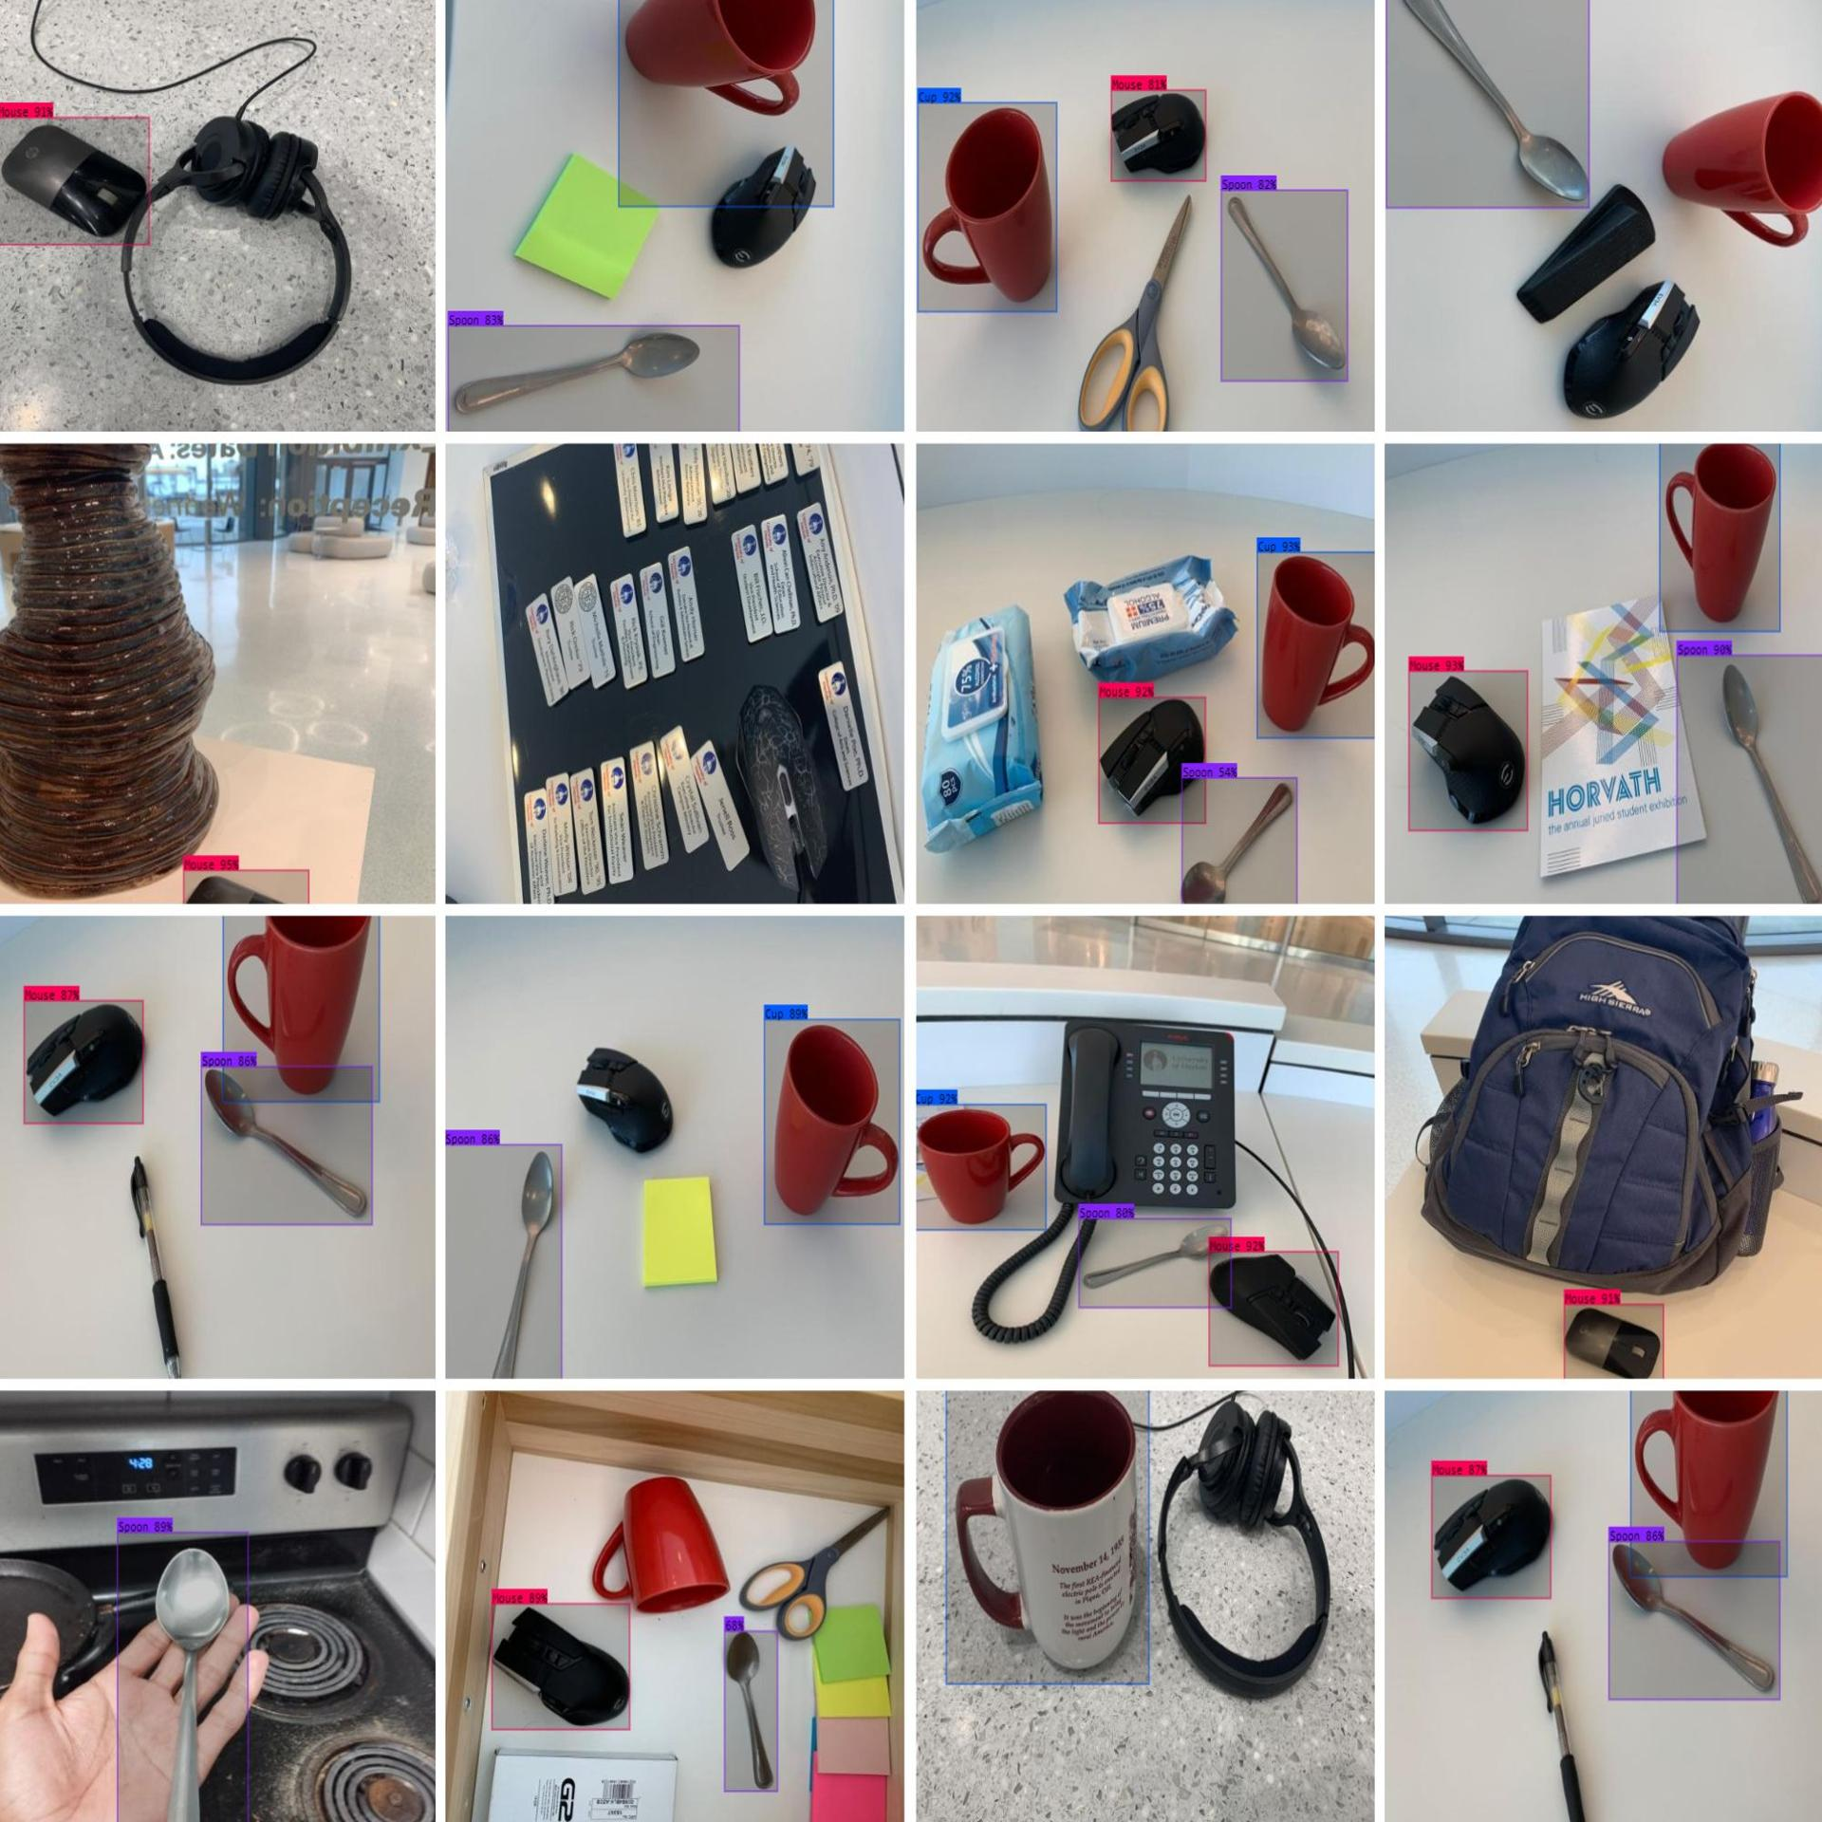

Conclusion:

In conclusion, our project successfully implemented an object detection model using the YOLO v8 architecture to identify mice, spoons, and cups in images. Through meticulous data collection, preprocessing, and annotation, we created a diverse dataset that enabled the model to learn and generalize well to unseen data. Leveraging tools like Roboflow for annotation streamlined the process and ensured accurate labelling of objects. The YOLO v8 model's efficiency and effectiveness were evident in its ability to detect and localize objects in real-time scenarios. Our model's performance was evaluated using various metrics, including precision, recall, and mean average precision (mAP), demonstrating its accuracy and reliability. Overall, the project showcased the practical application of computer vision in object detection, with potential use cases in inventory management, robotics, and other fields requiring object recognition. Future enhancements could include fine-tuning the model on additional data to improve its performance further and exploring deployment options for real-world applications. The project highlighted the importance of robust dataset creation, model selection, and thorough evaluation in developing effective object detection systems.